# FIIT STU

# MIKRO cvičenie 4,5,6

# 

# 

# 

# 

# 

Meno: Jakub Gašparín, Dušan Havlík

Cvičenie: Utorok 18:00-19:40

Cvičiaci: Ing. Vladimír Kunštár

Obsah

Úloha 1: 2

Úloha 2: 4

Úloha 3: 5

Úloha 4: 8

Úloha 5 16

Úloha 6: 20

Úloha 7: 23

Úloha 8: 23

Úloha 1:  
Arduino

Obrázok, na ktorom je text

Automaticky generovaný popis

Sekcia 20: 8x LED diódy

Obrázok, na ktorom je text

Automaticky generovaný popis

4-miestny 7-segmentový LED display:

Obrázok, na ktorom je text, predajný automat

Automaticky generovaný popis

spínače log 1

Obrázok, na ktorom je text, červené, ovládací panel

Automaticky generovaný popis

spínače log 0

Obrázok, na ktorom je text, motor

Automaticky generovaný popis

klávesnica 4x4

Obrázok, na ktorom je text

Automaticky generovaný popis

LCD display, sekcia 11:

Obrázok, na ktorom je text, elektronika, obvod

Automaticky generovaný popis

# Úloha 2:



Musíme si pozrieť stranu 259:

I = U/R

R = 2,2 ohmov

I = 20 mA



const uint8_t blink_pins[] = { 2, 3, 4, 5, 6, 7, 8, 9 };

int pin_index = -1;

int last_pin_index = 0;

void setup() {

  // put your setup code here, to run once:

  pinMode(2, OUTPUT);

  for (int i = 0; i < sizeof(blink_pins)/sizeof(uint8_t); i++)

  {

    pinMode(blink_pins[i], OUTPUT);

    digitalWrite(blink_pins[i], HIGH);

  }

  pin_index = 0;

  last_pin_index = 0;

}

void loop() {

  // put your main code here, to run repeatedly:

  digitalWrite(blink_pins[last_pin_index], HIGH);

  digitalWrite(blink_pins[pin_index], LOW);

  last_pin_index = pin_index;

  pin_index += 1;

  if (pin_index >= sizeof(blink_pins)/sizeof(uint8_t))

    pin_index = 0;

  delay(1000);

}

V tomto kóde sme si museli zadefinovať základné ledky a potom ich cez loop zapínať a vypínať.

# Úloha 3:

#define PA (2)

#define PB (3)

#define PC (4)

#define PD (5)

#define PE (6)

#define PF (7)

#define PG (8)

#define PDOT (9)

#define DIGIT_PIN_ROW (8)

const uint8_t all_pins[] = { PA, PB, PC, PD, PE, PF, PG, PDOT };

const int8_t digit_pins[] = {

  PG, PDOT, -1, -1, -1, -1, -1, -1, // 0

  PA, PD, PE, PF, PG, PDOT, -1, -1, // 1

  PC, PF, PDOT, -1, -1, -1, -1, -1, // 2

  PF, PE, PDOT, -1, -1, -1, -1, -1, // 3

  PA, PE, PD, PDOT, -1, -1, -1, -1, // 4

  PB, PE, PDOT, -1, -1, -1, -1, -1, // 5

  PB, -1, -1, -1, -1, -1, -1, -1, // 6

  PF, PG, PE, PD, PDOT, -1, -1, -1, // 7

  PDOT, -1, -1, -1, -1, -1, -1, -1, // 8

  PE, -1, -1, -1, -1, -1, -1, -1, // 9

};

void setup_digit_pins(void)

{

  for (int i = 0; i < sizeof(all_pins)/sizeof(uint8_t); i++) {

    pinMode(all_pins[i], OUTPUT);

    digitalWrite(all_pins[i], HIGH);

  }

}

void write_digit(uint8_t digit) {

  for (int i = 0; i < sizeof(all_pins)/sizeof(uint8_t); i++) {

    digitalWrite(all_pins[i], LOW);

  }

  if (digit > 9)

    return;

  int8_t *pinptr = &digit_pins[digit * DIGIT_PIN_ROW];

  while (*pinptr >= 0)

  {

    digitalWrite(*pinptr, HIGH);

    pinptr++;

  }

}

void setup() {

  setup_digit_pins();

}

int index = 0;

void loop() {

  write_digit(index);

  delay(1000);

  index += 1;

  if(index > 9)

  {

    index = 0;

  }

}

V tejto úlohe si bolo treba najprv. zadefinovať rôzne spustenia pre všetky cifry, každá cifra má iné vykreslenie na displeji. Ďalej sme cez for cyklus postupne vypísali všetky cifry na každej časti displeja jedna za druhou.

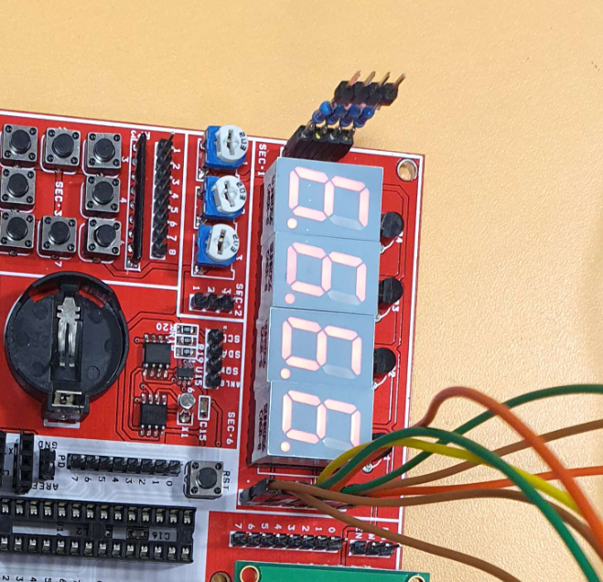

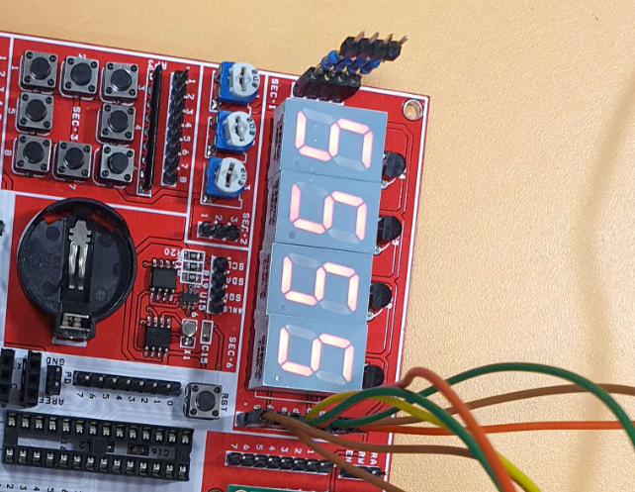

# Úloha 4:

#define PA (2)

#define PB (3)

#define PC (4)

#define PD (5)

#define PE (6)

#define PF (7)

#define PG (8)

#define PDOT (9)

#define PD1 (10)

#define PD2 (11)

#define PD3 (12)

#define PD4 (13)

#define DIGIT_PIN_ROW (8)

const uint8_t all_pins[] = { PA, PB, PC, PD, PE, PF, PG, PDOT };

const int8_t digit_pins[] = {

PG, PDOT, -1, -1, -1, -1, -1, -1, // 0

PA, PD, PE, PF, PG, PDOT, -1, -1, // 1

PC, PF, PDOT, -1, -1, -1, -1, -1, // 2

PF, PE, PDOT, -1, -1, -1, -1, -1, // 3

PA, PE, PD, PDOT, -1, -1, -1, -1, // 4

PB, PE, PDOT, -1, -1, -1, -1, -1, // 5

PB, -1, -1, -1, -1, -1, -1, -1, // 6

PF, PG, PE, PD, PDOT, -1, -1, -1, // 7

PDOT, -1, -1, -1, -1, -1, -1, -1, // 8

PE, -1, -1, -1, -1, -1, -1, -1, // 9

};

void setup_digit_pins(void)

{

for (int i = 0; i < sizeof(all_pins)/sizeof(uint8_t); i++) {

pinMode(all_pins[i], OUTPUT);

digitalWrite(all_pins[i], HIGH);

}

}

void write_digit(uint8_t digit) {

for (int i = 0; i < sizeof(all_pins)/sizeof(uint8_t); i++) {

digitalWrite(all_pins[i], LOW);

}

if (digit > 9)

return;

int8_t *pinptr = &digit_pins[digit * DIGIT_PIN_ROW];

while (*pinptr >= 0)

{

digitalWrite(*pinptr, HIGH);

pinptr++;

}

}

String input_string = "";

bool input_complete = false;

void setup() {

setup_digit_pins();

pinMode(PD1, OUTPUT);

pinMode(PD2, OUTPUT);

pinMode(PD3, OUTPUT);

pinMode(PD4, OUTPUT);

Serial.begin(9600);

input_string.reserve(256);

}

inline void select_digit(uint8_t i) {

if (i == 0) {

digitalWrite(PD1, LOW);

digitalWrite(PD2, HIGH);

digitalWrite(PD3, HIGH);

digitalWrite(PD4, HIGH);

} else if (i == 1) {

digitalWrite(PD1, HIGH);

digitalWrite(PD2, LOW);

digitalWrite(PD3, HIGH);

digitalWrite(PD4, HIGH);

} else if (i == 2) {

digitalWrite(PD1, HIGH);

digitalWrite(PD2, HIGH);

digitalWrite(PD3, LOW);

digitalWrite(PD4, HIGH);

} else if (i == 3) {

digitalWrite(PD1, HIGH);

digitalWrite(PD2, HIGH);

digitalWrite(PD3, HIGH);

digitalWrite(PD4, LOW);

}

}

void __aasdserialEvent() {

while (Serial.available()) {

char recv = (char) Serial.read();

input_string += recv;

if (recv == '\n') {

// do stuff

input_complete = true;

}

}

}

uint16_t frame_timer = 0;

uint8_t minuta = 59;

uint8_t sekundy = 30;

void loop() {

uint8_t cislo = minuta;

select_digit(1);

write_digit(cislo % 10);

digitalWrite(PDOT, LOW);

cislo /= 10;

delay(5);

select_digit(0);

write_digit(cislo % 10);

cislo /= 10;

delay(5);

cislo = sekundy;

select_digit(3);

write_digit(cislo % 10);

cislo /= 10;

delay(5);

select_digit(2);

write_digit(cislo % 10);

cislo /= 10;

delay(5);

// 20ms

frame_timer += 20;

if (frame_timer >= 1000) {

frame_timer = 0;

sekundy += 1;

if (sekundy >= 60) {

sekundy = 0;

minuta += 1;

if (minuta >= 60) {

minuta = 0;

}

}

}

while (Serial.available()) {

char recv = (char) Serial.read();

input_string += recv;

if (recv == '\n') {

uint8_t target = 0;

uint8_t i = 0;

uint8_t hodnota = 10;

for (i = 0; i < input_string.length(); i++) {

char c = input_string.charAt(i);

if (c == ':' || c == '\n' || c == ' ')

break;

target += (c - '0') * hodnota;

hodnota /= 10;

}

i += 1;

while (target >= 60)

target -= 60;

minuta = target;

target = 0;

hodnota = 10;

for (; i < input_string.length(); i++) {

char c = input_string.charAt(i);

if (c == '\n' || c == ' ')

break;

target += (c - '0') * hodnota;

hodnota /= 10;

}

while (target >= 60) {

minuta += 1;

target -= 60;

}

sekundy = target;

frame_timer = 0;

input_string = "";

}

}

//if (input_complete) {

// Serial.println(input_string);

// input_string = "";

// input_complete = false;

//}

}

Obrázok, na ktorom je text, elektronika, obvod

Automaticky generovaný popis

# Úloha 5

const uint8_t button_pins[] = { 2, 3, 4, 5, 6, 7, 8, 9 };

uint8_t last_value = 0;

uint8_t read_button(uint8_t which, uint8_t accumulatedValue) {

uint8_t pin = button_pins[which];

uint8_t mask = 1 << which;

uint8_t newValue = 0;

uint8_t currentValue = accumulatedValue;

uint8_t button = digitalRead(pin) << which;

if ((currentValue & mask) != button) {

if ((currentValue & mask) == mask) {

// 1 -> 0

delay(3);

newValue = digitalRead(pin) << which;

if (newValue == 0) {

return accumulatedValue & ~mask;

}

} else {

// 0 -> 1

delay(8);

newValue = digitalRead(pin) << which;

if (newValue == mask) {

return accumulatedValue | mask;

}

}

}

return currentValue;

}

uint8_t read_buttons(void) {

uint8_t value = 0;

value = read_button(0, value);

value = read_button(1, value);

value = read_button(2, value);

value = read_button(3, value);

value = read_button(4, value);

value = read_button(5, value);

value = read_button(6, value);

value = read_button(7, value);

return value;

}

void setup() {

pinMode(2, INPUT);

pinMode(3, INPUT);

pinMode(4, INPUT);

pinMode(5, INPUT);

pinMode(6, INPUT);

pinMode(7, INPUT);

pinMode(8, INPUT);

pinMode(9, INPUT);

Serial.begin(9600);

}

void loop() {

uint8_t value = read_buttons();

for (uint8_t i = 0; i < 8; i++) {

uint8_t mask = 1 << i;

if ((value & mask) != (last_value & mask)) {

if ((value & mask) == mask) {

Serial.print("Stlacil som ");

Serial.println(i);

} else {

Serial.print("Pustil som ");

Serial.println(i);

}

}

}

if (last_value != value) {

last_value = value;

}

}Obrázok, na ktorom je text

Automaticky generovaný popis

# Úloha 6:

#define ISLOG1 (1)

const uint8_t button_pins[] = { 2, 3, 4, 5, 6, 7, 8, 9 };

uint8_t last_value = 0;

uint8_t read_button(uint8_t which, uint8_t accumulatedValue) {

uint8_t pin = button_pins[which];

uint8_t mask = 1 << which;

uint8_t newValue = 0;

uint8_t currentValue = accumulatedValue;

uint8_t button = digitalRead(pin) << which;

if ((currentValue & mask) != button) {

if ((currentValue & mask) == mask) {

// 1 -> 0

delay(ISLOG1 ? 8 : 3);

newValue = digitalRead(pin) << which;

if (newValue == 0) {

return accumulatedValue & ~mask;

}

} else {

// 0 -> 1

delay(ISLOG1 ? 3 : 8);

newValue = digitalRead(pin) << which;

if (newValue == mask) {

return accumulatedValue | mask;

}

}

}

return currentValue;

}

uint8_t read_buttons(void) {

uint8_t value = 0;

value = read_button(0, value);

value = read_button(1, value);

value = read_button(2, value);

value = read_button(3, value);

value = read_button(4, value);

value = read_button(5, value);

value = read_button(6, value);

value = read_button(7, value);

if (ISLOG1) {

value ^= 255;

}

return value;

}

void setup() {

pinMode(2, INPUT);

pinMode(3, INPUT);

pinMode(4, INPUT);

pinMode(5, INPUT);

pinMode(6, INPUT);

pinMode(7, INPUT);

pinMode(8, INPUT);

pinMode(9, INPUT);

Serial.begin(9600);

}

void loop() {

uint8_t value = read_buttons();

for (uint8_t i = 0; i < 8; i++) {

uint8_t mask = 1 << i;

if ((value & mask) != (last_value & mask)) {

if ((value & mask) == mask) {

Serial.print("Stlacil som ");

Serial.println(i);

} else {

Serial.print("Pustil som ");

Serial.println(i);

}

}

}

if (last_value != value) {

last_value = value;

}

}

Obrázok, na ktorom je text

Automaticky generovaný popis

# Úloha 7:

XXXXXXXXXXXXXXXXXXXXXXXXXXXXXx

# Úloha 8:

#include <LiquidCrystal.h>

#define RA (2)

#define RW (3)

#define EN (4)

#define D0 (5)

#define D1 (6)

#define D2 (7)

#define D3 (8)

#define D4 (9)

#define D5 (10)

#define D6 (11)

#define D7 (12)

LiquidCrystal lcd(RA, RW, EN, D0, D1, D2, D3, D4, D5, D6, D7);

void setup() {

lcd.begin(16, 2);

lcd.clear();

}

void loop() {

lcd.setCursor(0, 0);

lcd.print("Dusan Havlik");

lcd.setCursor(0, 1);

lcd.print("Jakub Gasparin");

}

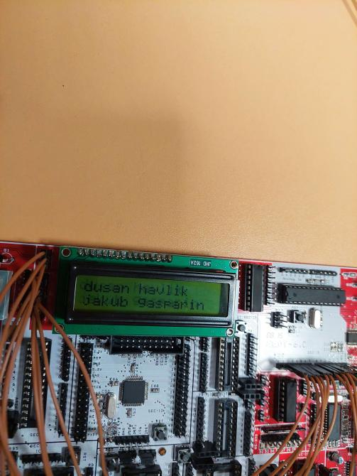

#include <LiquidCrystal.h>

#define RA (2)

#define RW (3)

#define EN (4)

#define D0 (5)

#define D1 (6)

#define D2 (7)

#define D3 (8)

#define D4 (9)

#define D5 (10)

#define D6 (11)

#define D7 (12)

LiquidCrystal lcd(RA, RW, EN, D0, D1, D2, D3, D4, D5, D6, D7);

uint8_t cursor_y = 0;

uint8_t cursor_x = 0;

void setup() {

// put your setup code here, to run once:

lcd.begin(16, 2);

lcd.clear();

Serial.begin(9600);

}

void print(char c) {

if (isprint(c)) {

if (cursor_x >= 16) {

cursor_x = 0;

cursor_y++;

}

if (cursor_y >= 2) {

lcd.clear();

cursor_x = 0;

cursor_y = 0;

}

lcd.setCursor(cursor_x, cursor_y);

lcd.write(c);

cursor_x += 1;

}

}

uint8_t control = 0;

void loop() {

// put your main code here, to run repeatedly:

while (Serial.available()) {

char c = (char) Serial.read();

if (control) {

if (c == 'c') {

lcd.clear();

cursor_x = 0;

cursor_y = 0;

}

control = 0;

continue;

}

if (c == '\\') {

control = 1;

continue;

}

print(c);

}

}

